
Daily SAS (4-7) and/or PSS (2) rating is moderate:
o Monitor daily with Daily SAS and PSS
‘Daily SAS (1-3) and /or PSS (1) rating is mild:
o Monitor weekly with Daily SAS and PSS
Daily SAS (0) and /or PSS (0) rating is absent for three continuous weeks:
o Cease Daily SAS and PSS unless triggered
Action: ANUM/RN/EN to complete PACOP PROFILE COLLECTION or Deteriorating Resident Tool (DRT)

AV = Ambulance Victoria
DRT = Deteriorating Resident Tool
EN = Enrolled Nurse
GP = General Practitioner

GRPCT = Grampians Regional
Palliative Care Team
PACOP = Palliative Aged Care Outcomes Program
PCAS = Palliative Care Advice Service

SAS = Symptom Assessment Scale
SPCN = Specialist Palliative Care Nurse
VVED = Victorian Virtual Emergency Department

Visit your ‘Highway to Help’ for easy access to resources on various topics
www.ac-pc.com.au
Contact details and business hours:
*GRPCT: Mon - Fri 8:00am - 4:00pm. Referral: 1. Send referral form (www.grpct.com.au/referral-form). 2: Phone triage on 0408 612699
**PCAS: 7:00am - 10:00pm, 365 days/ year. Phone: 1800 360 000. Web: pcas.org.au
***VVED: Virtual Emergency Department medical telehealth service; 24/7, 365 days/ year. Web: vved.org.au/aged-care. Device for Telehealth video consultation required
****AV RACER Pathway: Call 000 and identify patient as aged care resident. Device for Telehealth video consultation required
Actions following initial PACOP DRT assessment
Actions following Daily SAS monitoring
Outcomes collection: Response to palliative care needs - Stable, unstable and deteriorating phase
1. Advise resident, their family / friends, and GP of identified palliative care needs, STOP and WATCH Tool
2. Depending on SAS score:
o SAS score 4-5 for pain, breathing, bowel or nausea OR SAS score 4-10 for fatigue, appetite, sleeping or other symptoms: Request GP review
o Ongoing SAS score 6+ for pain, breathing problems, bowel problems or nausea: Refer to GRPCT*;
If GP or GRPCT are unavailable, contact:
a. Palliative Care Advice Service (PCAS)**
b. VVED*** if PCAS not available
c. 000 for AV RACER pathway**** if VVED consult not available
In all instances: Clarify GOC prior to request for review
3. Refer to GRPCT* if resident/family is asking for a specialist palliative care review
4. Document/review and revise symptom management plan(s)
5. Start monitoring with Daily SAS and PSS as outlined below:

Note: Daily SAS and PSS may be used in conjunction with other pain assessment tools, e.g. PainChek, PAINAD, Abbey Pain Scale.

NO
Systematic identification of and response to Palliative deterioration

Trigger points for PACOP PROFILE COLLECTION or short review with DETERIORATING RESIDENT TOOL (DRT) to identify deterioration

PSS = Problem Severity Score
RACER = Residential Aged Care Enhanced Response
RN = Registered Nurse

Abbreviations:
AN-ACC = Australian National Aged Care Classification
ANUM = Associate Nurse Unit Manager
6. Review Advance Care Plan and Goals of Care
7. Conduct case conference (potentially with GP and/or SPCN)
8. Conduct family meeting
9. Further actions as required:
o Referral(s) to Allied Health
o Access to equipment
o New AN-ACC assessment
o Referral for emotional and spiritual consultation
o Anticipatory prescribing for common end of life phase symptoms
PACOP ‘Daily SAS (8-10) and /or PSS (3) rating is severe’
o Monitor symptoms frequently as clinically indicated with Daily SAS and PSS until a reduced SAS/PSS rating is achieved

AV = Ambulance Victoria
DRT = Deteriorating Resident Tool
EN = Enrolled Nurse
GP = General Practitioner

GRPCT = Grampians Regional
Palliative Care Team
PACOP = Palliative Aged Care Outcomes Program
PCAS = Palliative Care Advice Service

PSS = Problem Severity Score
RACER = Residential Aged Care Enhanced Response
RN = Registered Nurse
SAS = Symptom Assessment Scale
SPCN = Specialist Palliative Care Nurse
VVED = Victorian Virtual
Emergency Department
• On admission
• Standard resident review process (Resident of the day, Resident in Focus, resident care plan review or similar)
• Upon return from hospital (Emergency Department/Urgent Care Centre or hospital admission)
• Changes in the resident observed by any staff member, complete in addition to acute assessment e.g. after a fall, change of cognition, delirium, antibiotics, loss of appetite, loss of weight, behavioural change, Stop and Watch tool.
• If requested by the resident, their family or friends

Palliative care needs identified?

YES

Dying phase: Response to end-of-life care needs

1. Advise resident, family of deterioration
2. Advise GP of deterioration
3. Conduct family meeting if required
4. Commence Care Plan for the Dying Person (end-of-life pathway)
5. Check anticipatory medications are charted and in stock, and required equipment is available
6. Complete Daily SAS and PSS during each shift to monitor symptoms
=> Escalate for urgent review to GP if SAS score is 4-5 or to GRPCT if SAS score 6+ for pain, breathing problems, bowel problems or nausea
7. Organise emotional or spiritual consultation if needed
8. Offer bereavement support for family, carers and friends (e.g. referral to internal Social Worker or provision of information on external bereavement support)

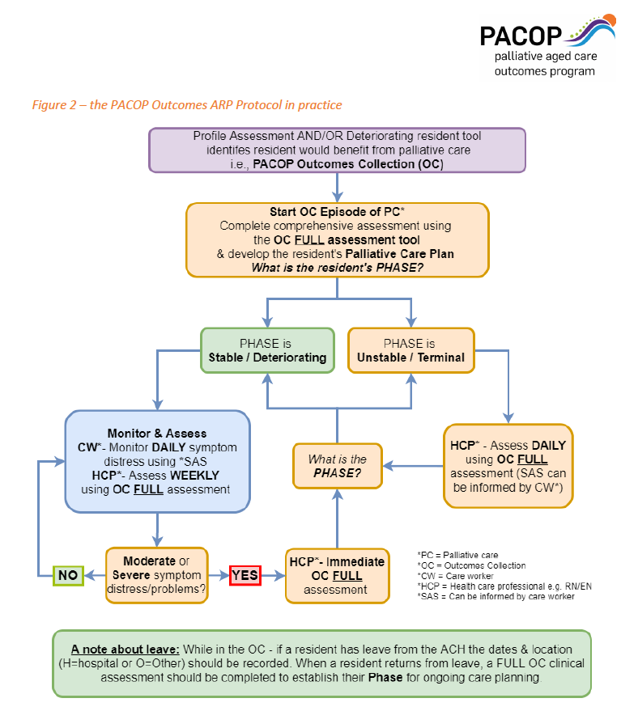

Source: PACOP Outcomes ARP ‘Protocol in Practice’ (ARP PiP) , p. 2.

